- 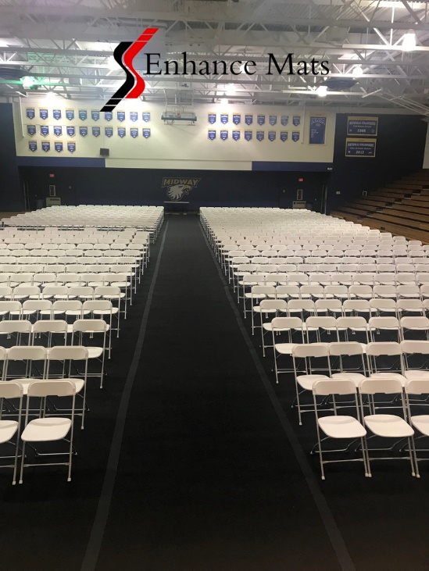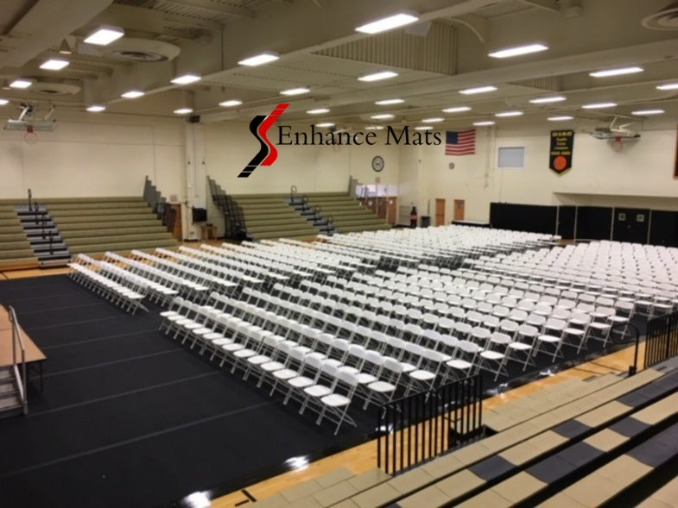
- 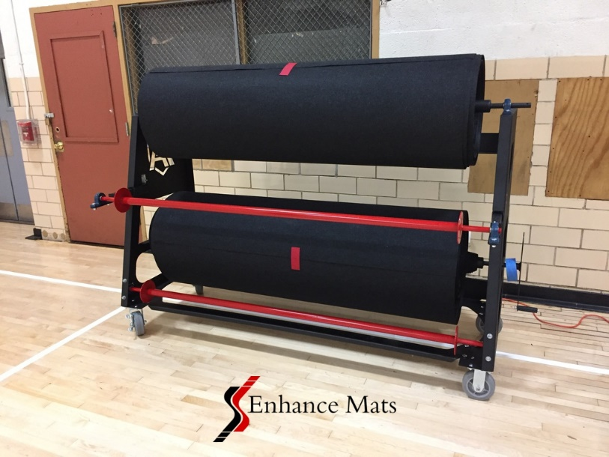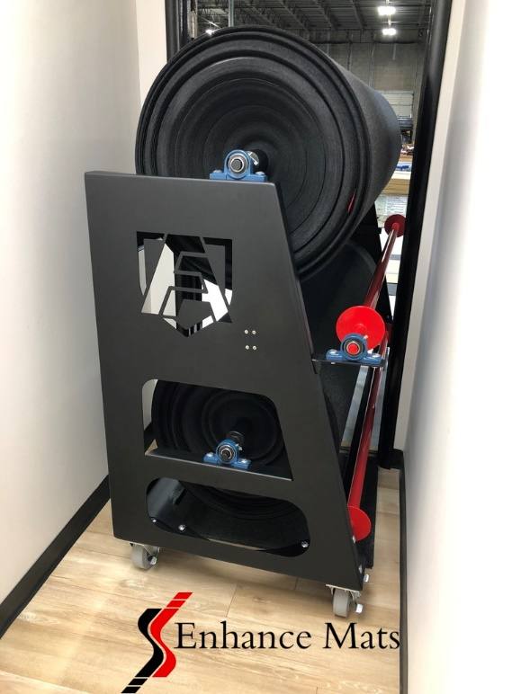

- 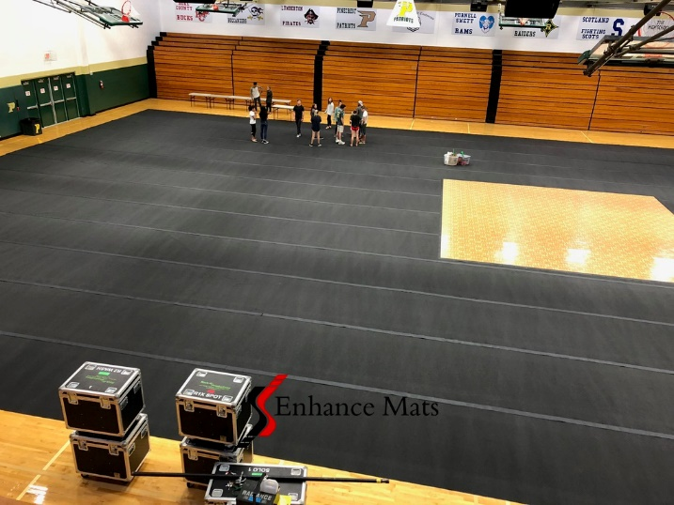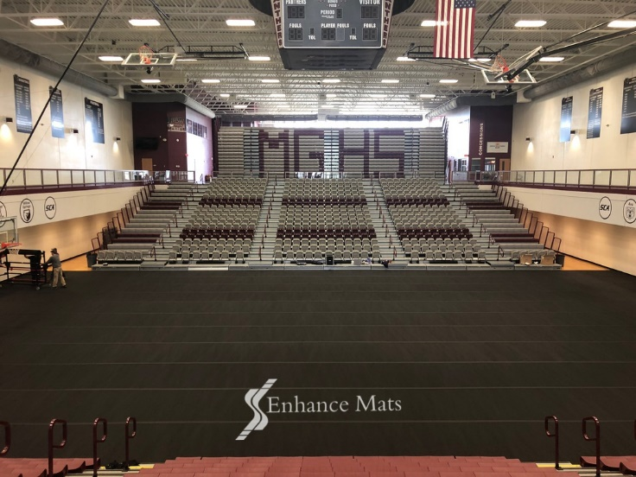

- 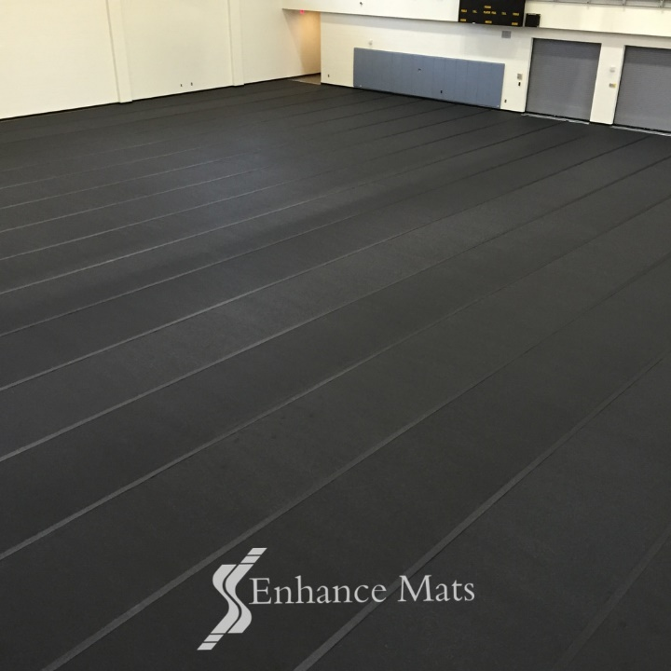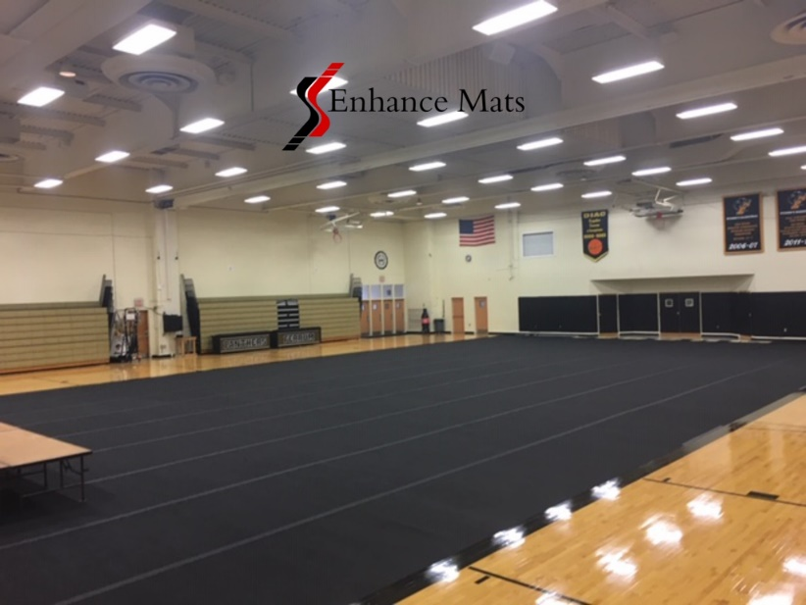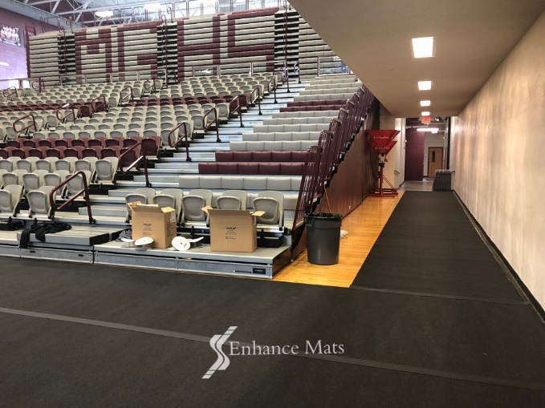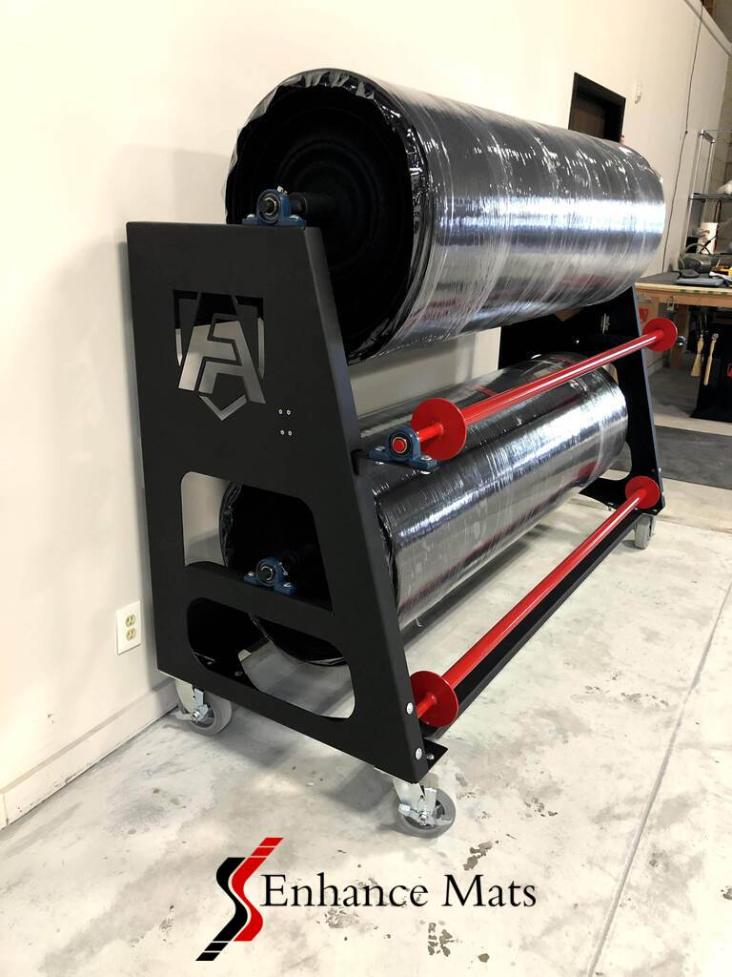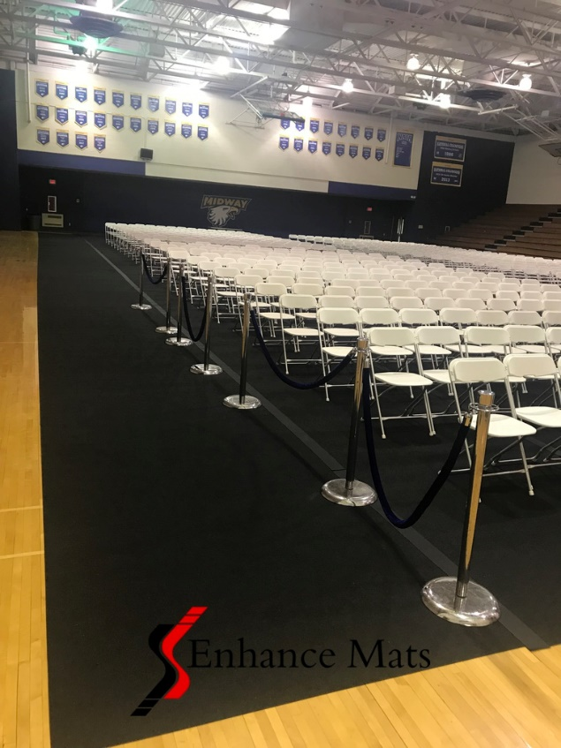

- 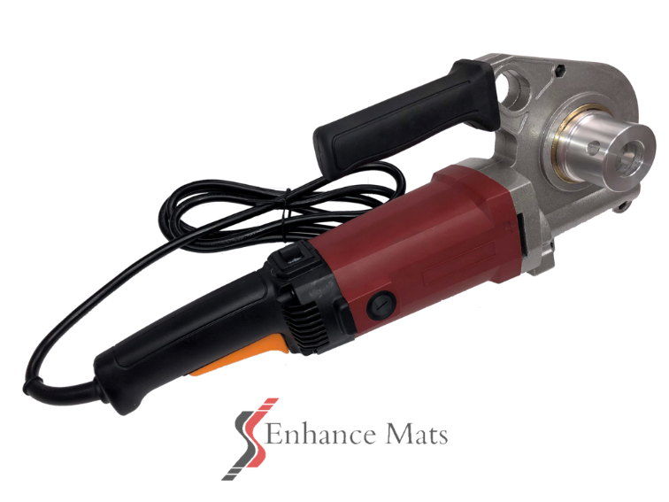

COURT ARMOR ROLLS- BEST GYM FLOOR COVERS AND GYM FLOOR COVERING

Enhance Mat’s Court Armor Rolls are high quality, budget friendly cover systems that protect your Gym Floors. Quick & Easy installation with Compact Storage Racks & Power Winder! Quick ship.

COURT ARMOR ROLLS is the new era of gym floor protection.
- Protect your gym floor with Court Armor Rolls by Facility Armor, a 100% recycled polyester nonwoven top cloth fused together with a non-skid, extruded, moisture barrier backing. Anti-Microbial Protected.
- Our New Court Armor gym cover rolls are economical, quick and easy to install, take up, and best of all easy to store.
- Stain and tear resistant, the Court Armor Rolls have a carpet top cloth that provides noise dampening with an attractive appearance for any special event.
- The moisture wicking top cloth wicks any spills, preventing slip and fall accidents while the slip resistant backing safely keeps any spills from damaging your floors.
- With the added Anti-Microbial protection you can feel safe knowing that your gym floor cover will remain mold, mildew, germ, virus and odor free for the life of your product.
- Quick and easy storage on compact racks that require half the space of the larger vinyl storage racks, are easy to transport and hold 7000 sq. ft per rack.
Court Armor Rolls are superior gym floor protection against damage caused by spills, street shoe traffic, chairs, staging and equipment. Easily transform your gym for special events, commencements, banquets, trade shows, church services and graduations.
** Reusable Hook Seaming System. No Adhesive Tape!
Better Looking! Faster Install!
10X’s More Cost Effective Than Tape
Our hook tape can be reused 50 times vs. one-time use tape!

MADE IN AMERICA

FEATURES AND BENEFITS:
- Extremely Light Weight, Durable, & Tear Resistant
- Fast and Easy Installation and Take Up
- Anti-Microbial Protected
- Noise Dampening Carpet Top Cloth
- Highly Slip, Stain and Tear Resistant
- Safe, ADA compliant
- Easy to Clean
- Compact Storage Rack holds 7000 sq ft
- Top Hook Seaming Tape Included

SPECIFICATIONS:
Color: Charcoal
Roll Width: 6 ft.
Roll Length: Customer Specified
Weight: 16.5 oz per YD2
Warranty: 4 Years
Fire Rating: ASM E648-06 Class 1

Court Armor Rack Storage System: Fits through a standard door!
The Court Armor Rack system is constructed of high gauge steel and holds a total capacity of 7,000 square feet of matting. There are spindles, each holds 3,500 square feet of matting. Each spindle can hold multiple lengths of mats. Non-marking castors. Approx. weight 255 lbs.

Power winder available.

QUESTIONS?

CALL US DIRECTLY @ 877.318.8625

HOW MUCH WILL GYM FLOOR PROTECTION COST

RELATED ITEMS
Court Armor Tile
Side Armor: Courtside Runners

